Task No & Title: | BSBCMN211A Participate in workplace safety procedures
Title: | Ergonomics Quiz
Suitable for Classes: | Certificate II Business Cert II in ICT
Area: | Technology & Enterprise
Teacher: | Mr Peter Faulks
Timeline | 2 hours
Date Due: | Today

Task Brief:
Files Required | Pen pencil only

Items highlighted in yellow are tasks for you to complete
Items in Blue are help tips

Ergonomic Quiz 2 Written Questions

Note this quiz can be split into several quizzes

Select the alternative that correctly answers the following questions.

1 Who is considered most as risk from VDU radiation?

(a) Pregnant women
(b) Teachers
(c) Office staff
(d) Computer technicians

2 A small computer lab is set up as per the diagram below. What is the ergonomic disadvantage of this arrangement?
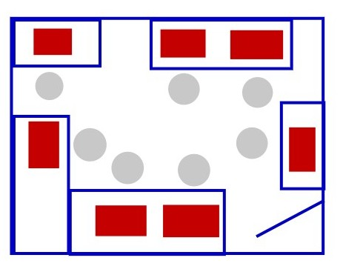
(a) Teacher can monitor each student.
(b) Middle of the room is open.
(c) No group discussion table.
(d) Students have to turn to watch the teacher.

3 When selecting computer tables which of the following features should NOT be considered?

(a) Provide enough working space
(b) Top should be laminated
(c) Should not be too low
(d) Allow access for people in wheelchairs

4 Keyboard drawers or trays are built into some workstations. Keyboard drawers are thought to be deficient in which area?

(a) Smaller keys
(b) No provision for a mouse
(c) More leg room
(d) Less noise
5 Which of the following is NOT a method that is used to help prevent carpal tunnel syndrome?

(a) Proper seating
(b) Adjustable table height
(c) Anti-glare screen
(d) Feet on the floor

6 Which of the following could be the cause of eyestrain at a computer workstation?

(a) Direct light source
(b) Anti-glare screen
(c) A computer hood
(d) Window treatments (curtains)

7 In most schools many students of different ages and sizes use computers – yet there are limited ergonomic factors implanted into computer labs. For many, it is cost related. Which of the following would be a cost effective solution to relieve this problem?

(a) Regular exercise breaks
(b) Implementing a laptop program
(c) Provide ergonomically designed rooms and workstations
(d) All of the above

8 What are the best features to look for when selecting an ergonomic chair?

(a) Lumber support and wheels
(b) Adjustability and cloth covered
(c) Padded back and arm rests
(d) Lumber support and adjustability.

9 To help prevent neck pain when working at a computer the top of the screen should be positioned so that it is:

(a) Above eye level
(b) Below eye level
(c) At or below eye level
(d) At or above eye level

10 Use the diagram below to decide which is the best location, ergonomically, for a computer to be placed.

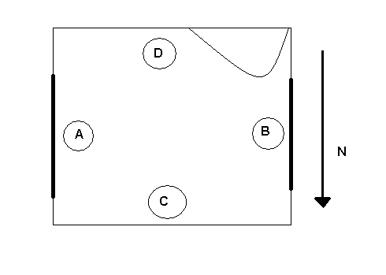
window
window
Door

(a) A
(b) B
(c) C
(d) D
True / False

1 Ergonomics is a science concerned chiefly with description and analysis of the production, distribution, and consumption of goods and services.
True / False

2 Reflected glare can be caused by shadows on the monitor.

True / False
3 When repeated stress is placed on tendons and muscles, this can result in a Cumulative Trauma Disorder.

True / False
4 Ergonomics is only a concern for people who work with computers.

True / False
5 If your wrists are at an angle when typing, then you should try putting the keyboard on your lap.
True / False

6 When working on a wireless LAN, users should avoid working where the radio waves are being transmitted.

True / False
7 The advantage of this type of computer room arrangement is that all students face the front.
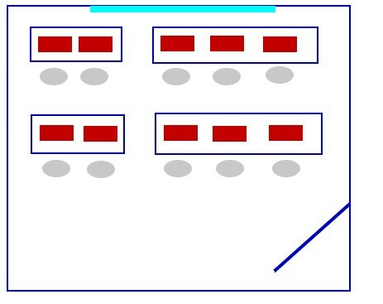
True / False
8 People who use laptop computers over extended periods of time should consider getting an external keyboard.
True / False

9 Armrests on chairs are designed to reduce loads on your spine.

True / False
10 A standard office desk would be appropriate for a computer workstation.

True / False

Match the Word to the Statement

A - RSI E - biomechanics

B - Workstation F - trackball

C - CTD’s G - posture

D - dvorak H - lumbar support

1 ____ A keyboard design where most commonly used letters are positioned under the user’s strongest fingers.

2 ____ An essential component for an ergonomic chair.

3 ____ The entire work area accessed by a worker when performing their job.

4 ____ Injuries that occur from repeated physical movements.

5 ____ Allows you to move the cursor, while keeping your arm in fixed position.

6 ____ This is a term used for injuries that occur over a period of time due to repeated trauma.

7 ____ The position of the body and its limbs.

8 ____ This is the study of the effect of forces on the human body in movement and at rest.

END of QUIZ

